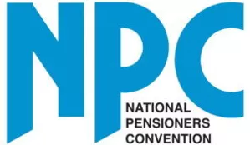
Campaigning for the rights of older people
**NEWS – Immediate Release**

NPC members take to streets for 11th hour socially-distanced demos over axing of free TV licences
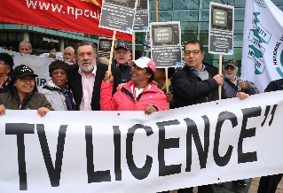

Britain’s biggest campaign group for older people will demonstrate tomorrow (Thursday 30th July) in a bid to save the free TV licence for over all 75’s before it is axed on Saturday.
Despite the ongoing threat of the pandemic, the fittest members of the National Pensioners’ Convention are staging ‘safe and socially distanced’ actions at several locations around the country.
They want the government and the BBC to stop the broadcaster imposing the £157.50 licence fee on our oldest and most vulnerable before the 1st August deadline.
Protests are planned in London, Newcastle, Oxford, Norwich, Liverpool, Irvine and Belfast, with many more members staging social media protests from the safety of their homes.
Jan Shortt, General Secretary of the NPC said: “The free TV licence for all over 75’s is a universal entitlement to supplement our poor state pension. To force people to find the money to pay for it now, particularly during the pandemic when they rely on their TV’s for information, is just cruel.”
“That is why on Thursday, the fittest and healthiest of our older members will put on their masks and gloves - and pop sanitiser in their pockets - to join static, and socially distanced demonstrations around the country.
“This is a big step for an age group that has been in lockdown longest and are just getting to grips with coming out of their homes. For that reason, we do not expect great numbers to attend, but those who are able to, want to show just how angry all of us feel at the loss of this important benefit for our oldest and most vulnerable citizens.
“We hope the Prime Minister – who promised last November to save the free licence for over 75’s – and the BBC, hear how much distress will be caused by their actions and take immediate steps to reverse their decisions.”
NPC protests will be happening in the following places on Thursday, 30th July:
- London
10 Downing Street, 11:15am to 12 noon.
- Norwich
BBC Studios at the Norwich Forum, from 11.30am.
- Oxford
Bonn Square, from 12 noon.
- Newcastle
BBC (Pink Palace) in Newcastle, 11.00 am until 11.30 am
- North London
Hornsey Pensioners, BBC TV Tower, Alexandra Palace, 11.00am to 11.30am.
- Liverpool
Merseyside Pensioners Association online Zoom protest at 7pm.
- Northern Ireland
Static demo of 30 people outside BBC Belfast on Friday, 31st (time tbc).
- Ayrshire, Scotland
All day protest in Irvine town centre, Saturday, 1st August.

The NPC is also continuing to push its social media campaign encouraging supporters to retweet the NPC’s message on its Twitter page to the Prime Minister. NPC members who are unable to go out because they are still shielding are asked to send pictures and videos of their own home-based protests to info@npcuk.org
ENDS
*For more information about the NPC protests on Thursday morning, 30th July, 2020 please contact Bev Morrison, 07588 779515 or Jan Shortt, 07773 051210.
*The National Pensioners Convention was set up in 1979 to champion the rights and welfare of the UK’s older people. It now represents more than 1.5 million people in over 1,000 different organisations across the UK and holds an Annual Convention – a pensioners’ parliament - to debate issues affecting older people.
www.npcuk.org
Beverley Morrison
Campaign & Media Officer

National Pensioners Convention
​Telephone: 07588 779515
bevmorrison@npcuk.org or info@npcuk.org

